E
E
S. Lucia  2023  …  www.legnani.eu/SLucia by joe © |   Period of holidays and gifts…  The best present? | A book?  A sweater?,  A tie,  a foulard?  an ornament?  a jewel? …?  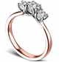 | A thank you for a little thing, already forgotten, a long time ago.  …(s)he sat near, in silence  and smiled.

E
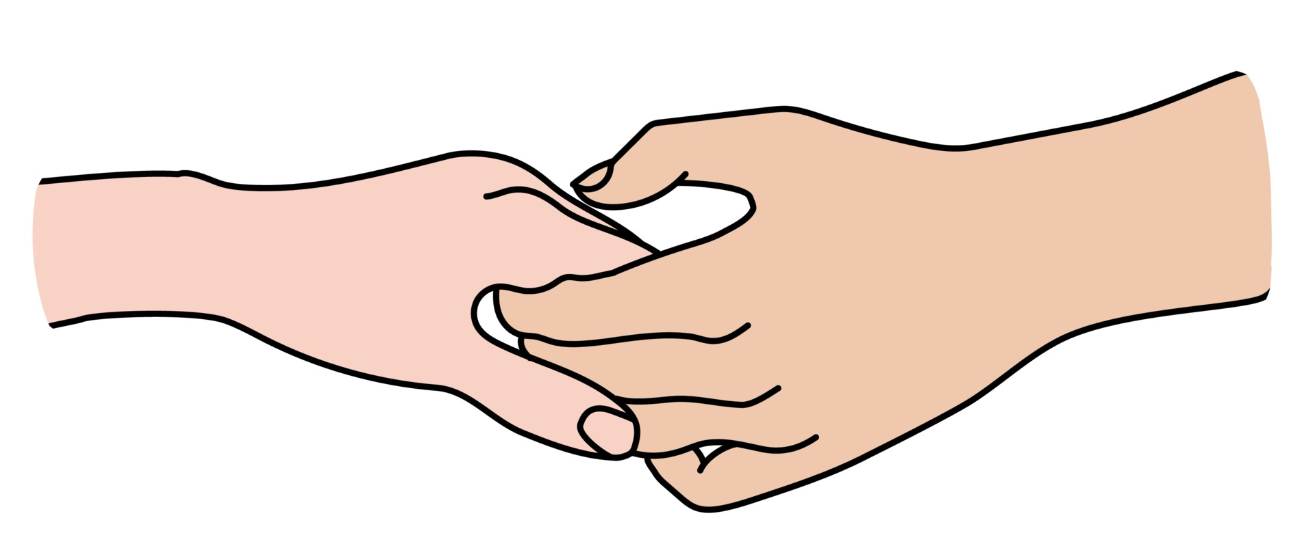  You messed up, but (s)he smiles.  A moment together, with serenity. |   Your name sweetly pronounced.  A silence that is worth  more than a thousand words. | The tone of voice (s)he speaks to you.  A glance that makes you realize that you are not alone.   |   Your smile when you read this booklet. | E

E
E
S. Lucia  2023  …  www.legnani.eu/SLucia by joe © | Period of holidays and gifts…  The best present? | A book?  A sweater?,  A tie,  a foulard?  an ornament?  a jewel? …? | A thank you for a little thing, already forgotten, a long time ago.  …(s)he sat near, in silence  and smiled.

E
You messed up, but (s)he smiles.  A moment together, with serenity. | Your name sweetly pronounced.  A silence that is worth  more than a thousand words. | The tone of voice (s)he speaks to you.  A glance that makes you realize that you are not alone. | Your smile when you read this booklet. | E

E
E
S. Lucia  2023  …  www.legnani.eu/SLucia by joe © | Period of holidays and gifts…  The best present? | A book?  A sweater?,  A tie,  a foulard?  an ornament?  a jewel? …? | A thank you for a little thing, already forgotten, a long time ago.  …(s)he sat near, in silence  and smiled.
E
You messed up, but (s)he smiles.  A moment together, with serenity. | Your name sweetly pronounced.  A silence that is worth  more than a thousand words. | The tone of voice (s)he speaks to you.  A glance that makes you realize that you are not alone. | Your smile when you read this booklet. | E

