E
E
S. Lucia  2024  With the eyes and heart of a child.  www.legnani.eu/SLucia by joe © |   Boys can see adventure in a dirty old duck puddle [B-P] | Adults never understand anything on their own and it is hard for children to continuously explain.  Le Petit Prince (A. de Saint-Exupéry) | All adults were first children.  (But few of them remember it).  (A. de Saint-Exupéry)  …unless you change and become like little children, you will never enter the kingdom of heaven.  [Mt 18,3]

E
Children must be very indulgent towards  adults.  (A. de Saint-Exupéry)  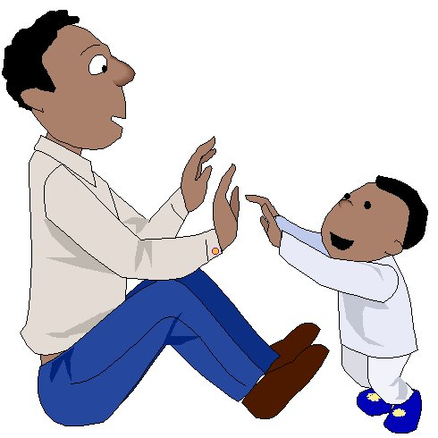 | The simplest joys,  are the most beautiful.  And they are the most important.  (S. Francesco) | but…  … when we have to part, you will weep …  If you want me as a friend: tame me.  I will be for you unique in the world.  Le Petit Prince (A. de Saint-Exupéry)  ) | 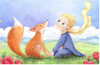  …please:  tame me! | E

E
E
S. Lucia  2024  With the eyes and heart of a child.  www.legnani.eu/SLucia by joe © | Boys can see adventure in a dirty old duck puddle [B-P] | Adults never understand anything on their own and it is hard for children to continuously explain.  Le Petit Prince (A. de Saint-Exupéry) | All adults were first children.  (But few of them remember it).  (A. de Saint-Exupéry)  …unless you change and become like little children, you will never enter the kingdom of heaven.  [Mt 18,3]

E
Children must be very indulgent towards  adults.  (A. de Saint-Exupéry) | The simplest joys,  are the most beautiful.  And they are the most important.  (S. Francesco) | but…  … when we have to part, you will weep …  If you want me as a friend: tame me.  I will be for you unique in the world.  Le Petit Prince (A. de Saint-Exupéry)  ) | …please:  tame me! | E

E
E
S. Lucia  2024  With the eyes and heart of a child.  www.legnani.eu/SLucia by joe © | Boys can see adventure in a dirty old duck puddle [B-P] | Adults never understand anything on their own and it is hard for children to continuously explain.  Le Petit Prince (A. de Saint-Exupéry) | All adults were first children.  (But few of them remember it).  (A. de Saint-Exupéry)  …unless you change and become like little children, you will never enter the kingdom of heaven.  [Mt 18,3]
E
Children must be very indulgent towards  adults.  (A. de Saint-Exupéry) | The simplest joys,  are the most beautiful.  And they are the most important.  (S. Francesco) | but…  … when we have to part, you will weep …  If you want me as a friend: tame me.  I will be for you unique in the world.  Le Petit Prince (A. de Saint-Exupéry)  ) | …please:  tame me! | E | nnnnnnnnnnnnnnnnnnnnnnnn

